Overview of Project

The purpose of this analysis was to analyze the entire data set to determine the best performing stocks from the data in a clear and concise manner, while also editing the code to optimize performance compared to the original VBA code.

Results

The refactored code ran a lot faster than the original code on the similar data set. The output found that ENPH and RUN were the only stocks to have a positive return while also have two of the three highest volumes among the 12 stocks. The code is able to handle more stock tickers by adding the desired ticker to the array and updating the total number of arrays in the code.

Refactored Code Run Time Original Code Run Time

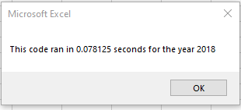 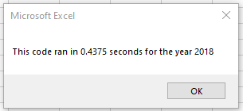

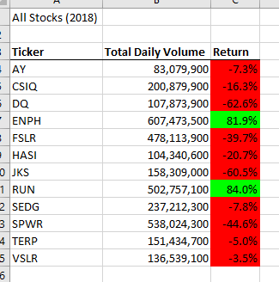 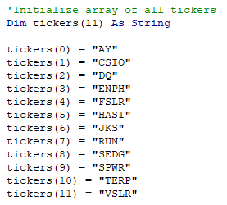

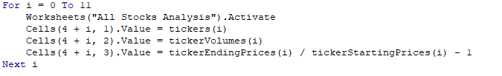

Summary

Some advantages of the refactored code is how quickly it was able to calculate the volume and return, but also the scalability of the code. For future calculations, one could simply add the ticker needed to the array and recalculate for the new figures. The only con regarding the refactored code was in regards to the code’s set up and ensuring syntax was correct in order to populate the output table correctly. Compared to the DQ Analysis sheet, making sure the loops were in the correct place and throughout the code, but once it was completed, the code now has the scalability to grow as the data set grows.